"FATTENING YOURSELF FOR SLAUGHTER"
Testing Your Faith by Your Craving for Wealth
James 5:1-6

W
ealth and our attitude toward riches has been discussed earlier in the book of James. Here are some examples:

1:9-11 ⁹ Believers in humble circumstances ought to take pride in their high position. ¹⁰ But the rich should take pride in their humiliation—since they will pass away like a wild flower. ¹¹ For the sun rises with scorching heat and withers the plant; its blossom falls and its beauty is destroyed. In the same way, the rich will fade away even while they go about their business.
2:1-4, 62 ¹My brothers and sisters, believers in our glorious Lord Jesus Christ must not show favoritism. ² Suppose a man comes into your meeting wearing a gold ring and fine clothes, and a poor man in filthy old clothes also comes in. ³ If you show special attention to the man wearing fine clothes and say, “Here’s a good seat for you,” but say to the poor man, “You stand there” or “Sit on the floor by my feet,” ⁴ have you not discriminated among yourselves and become judges with evil thoughts?
⁶ But you have dishonored the poor. Is it not the rich who are exploiting you? Are they not the ones who are dragging you into court? ⁷ Are they not the ones who are blaspheming the noble name of him to whom you belong?
4:13-14 ¹³ Now listen, you who say, “Today or tomorrow we will go to this or that city, spend a year there, carry on business and make money.” ¹⁴ Why, you do not even know what will happen tomorrow.
Now James returns to the subject and speaks about the dangers of coveting financial riches.
TEXT

"¹Now listen, you rich people, weep and wail because of the misery that is coming upon you. ²Your wealth has rotted, and moths have eaten your clothes. ³Your gold and silver are corroded. Their corrosion will testify against you and eat your flesh like fire. You have hoarded wealth in the last days. ⁴Look! The wages you failed to pay the workman who mowed your fields are crying out against you. The cries of the harvesters have reached the ears of the Lord Almighty. ⁵You have lived on earth in luxury and self-indulgence. You have fattened yourselves in the day of slaughter. ⁶You have condemned and murdered innocent men, who were not opposing you." (James 5:1-6)

OUTLINE

I. Coveted Wealth Corrodes (2-3)

II. Coveted Wealth Corrupts (3-6)

A. Greed Can Turn You into a Hoarder (3b)

B. Greed Can Turn You into a Robber (4)

C. Greed Can Turn You into a Glutton (5)

D. Greed Can Turn You into a Murderer (6)

III. Coveted Wealth Condemns (4-6, 9)

INTERACTIVE QUESTIONS

These questions will help you understand and apply the text. You can use them personally or with a group or study partner.

5:1-6 Testing Your Faith by Your Craving for Wealth

1. Is wealth a sin?

2. How much does it take to be considered rich in your community?

3. Who should "weep and wail"? Why? (5:1-6)

4. List the three sins of these wealthy people James is referring to.

5. How have rich people hurt others? (5:4-6)

6. What does James imply about the use of power and wealth?

7. What do luxury and self-indulgence have to do with the trouble that lays ahead for rich people? (5:5)

8. How can we use money to reflect what is important to God?

Please prepare for the next study by reading James 5:7-12
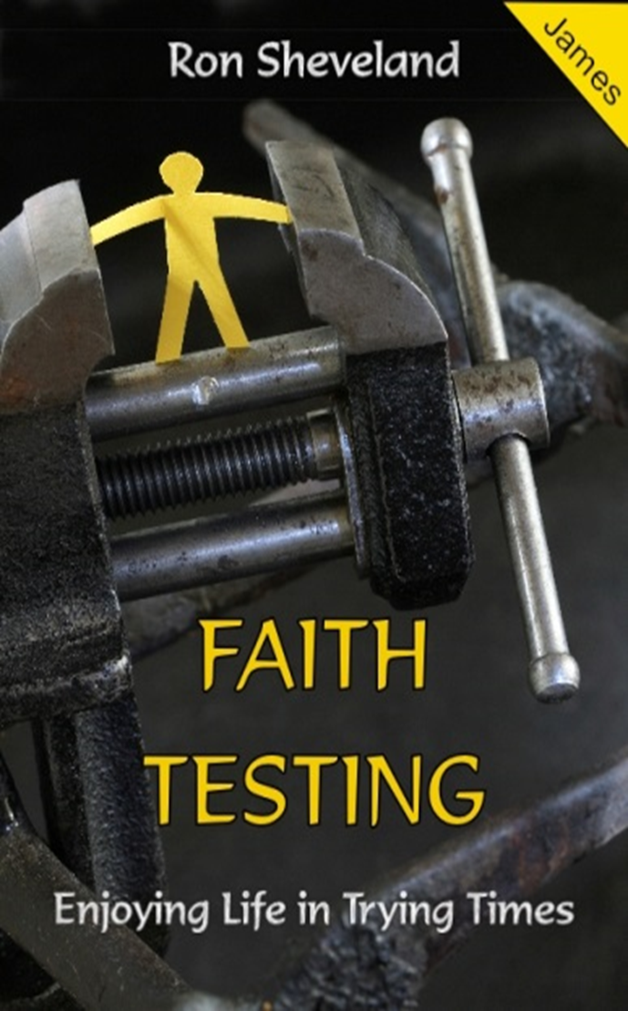
#12
"THE BEST LAID PLANS"
James 5:1-6

