$TATUS:
Testing Your Faith by Wealth
James 1:9-12

T
he book of James is built upon this proposition: The quality of your life depends upon the quality of your faith. Since that's true, we need a process for examining and improving the vitality of our faith. That is exactly what the book of James does. It provides a series of faith tests that you can use to evaluate and expand your spiritual life.

In our first study we saw how to confront the various trials that come into our lives. If you, with God’s help, will CHOOSE to face your trials with joy, RECOGNIZE that trials lead to triumph, and PRAY for God’s wise perspective, you will be able to handle any trial that comes your way. Here's another way to say it. The key to "considering" trials with joy is "knowing" that trials handled with faith result in triumph (adversity leads to tenacity, tenacity leads to maturity and maturity leads to vitality). The key to knowing that there will be great results is faith-based praying.

Now James takes us deeper into the sphere of faith testing and makes us deal with the temptations that are inherent in trials. Before he explains the anatomy of temptation, he provides a case study on "Wealth and Status." He will return to this theme frequently but in this visit we are invited to see the temptations involved when we let our wealth determine our sense of security and significance.

TEXT

^{1:9} The brother in humble circumstances ought to take pride in his high position. ¹⁰ But the one who is rich should take pride in his low position, because he will pass away like a wild flower. ¹¹For the sun rises with scorching heat and withers the plant; its blossom falls and its beauty is destroyed. In the same way, the rich man will fade away even while he goes about his business. ¹²Blessed is the man who perseveres under trial, because when he has stood the test, he will receive the crown of life that God has promised to those who love him.
OUTLINE

I. The Test of Poverty (1:9)

A. The Lie: Those who have little of worth are of little worth.

B. The Consequence: Those who believe the lie will miss out on the life of luxury that belongs to their high spiritual status.

II. The Test of Prosperity (1:10-11)

A. The Lie: Those who have much of worth are of much worth.

B. The Consequence: Those who believe this lie will miss out on the life of luxury that belongs to their high spiritual status.

III. The Life of Luxury (1:12)

INTERACTIVE QUESTIONS

These questions will help you understand and apply the text. You can use them personally or with a group or study partner.

1. How might the presence or absence of wealth affect a person's sense of security and significance?

2. What are some of the temptations facing those who have little? What is the key temptation implied in this passage? (1:9)

3. What is the "high position" that still belongs to a Christian "in humble circumstances?"

4. How do we resist the temptation to focus on our circumstances and instead focus on our standing? How can a person who pursues wealth and riches be disappointed?

5. What will eventually happen to the wealth of a rich person? (1:10-11)

6. In what way have material possessions disappointed you once you possessed them?

7. How much money would it take to make you consider yourself rich?

8. What reward awaits the person who perseveres under trial? (1:12)

9. How do vv. 9-12 relate to the process of thought in chapter 1?

10. How can you change the way you look at wealth this week so that you value it as God does?

Please prepare for the next study by reading James 1:13-18
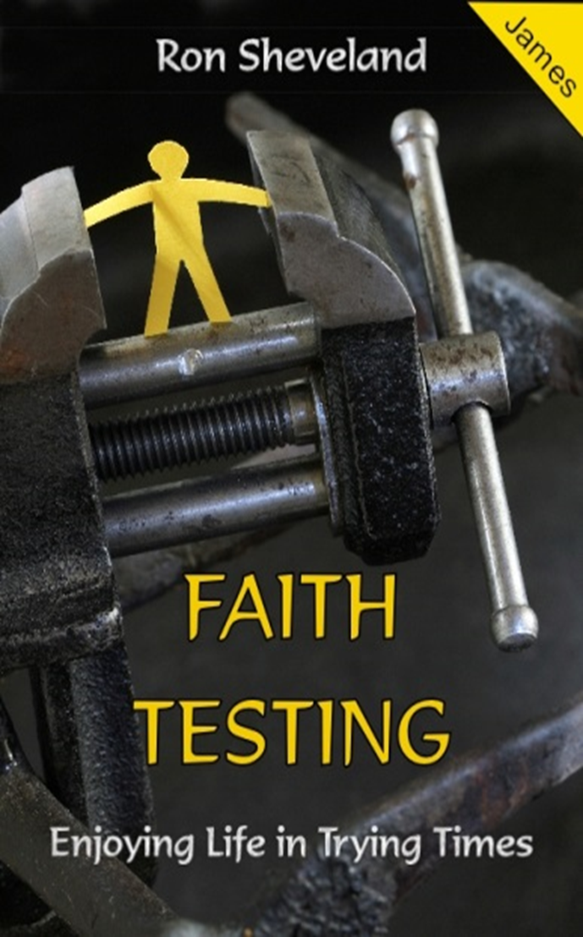
#2
$TATUS: Testing Your Faith by Wealth
James 1:9-12

