THE BAIT & THE HOOK
Testing Your Faith by Temptation
James 1:13-18

T
he quality of your life depends on the quality of your faith. God allows you to go through trials so that the quality of your faith can be tested and improved. Those who persevere will experience the joyful existence described as the "crown of life." It is this outcome that allows you to view trials with joy. This doesn't mean that the trials, in and of themselves, are joyous. They are difficult and burdensome. And inherent within them is the temptation to cave in under their pressure. This temptation is the subject of today's text.
James provides an in-depth study about how temptation works. On the negative side, we probe the downward spiral from temptation to sin and death. But then we gain practical help on how we can conquer temptation and experience righteousness and life.

TEXT AND CONTEXT

(12) Blessed is the man who perseveres under trial, because when he has stood the test, he will receive the crown of life that God has promised to those who love him. (13)When tempted, no one should say, "God is tempting me." For God cannot be tempted by evil, nor does he tempt anyone; (14)but each one is tempted when, by his own [evil] desire, he is dragged away and enticed. (15)Then after desire has conceived, it gives birth to sin; and sin, when it is full-grown, gives birth to death. (16)Don't be deceived, my dear brothers. (17)Every good and perfect gift is from above, coming down from the Father of the heavenly lights, who does not change like shifting shadows. (18)He chose to give us birth through the word of truth, that we might be a kind of firstfruits of all he created.

(20)… the righteous life that God desires. (21)Therefore, get rid of all moral filth and the evil that is so prevalent and humbly accept the word planted in you, which can save you.
(25) But the man who looks intently into the perfect law that gives freedom, and continues to do this, not forgetting what he has heard, but doing it--he will be blessed in what he does.
OUTLINE

I. During Trials You Will Be Enticed By Temptation To Experience That Which Brings Sin and Death.

A. Temptation Appeals to Evil Desires
(word of deception)
B. Consent Conceives Sin
C. Sin Gives Birth to Death

II. During Trials You Will Be Invited By God To Experience That Which Brings Righteousness and Life.

A. God Appeals to Good Desires
(Word of truth)
B. Consent Conceives Righteousness
C. Righteousness Gives Birth to Life

III. The Choice You Make Will Be Based On Your View Of God's Character.

A. Believe that God is Good.
1. God desires us to have victory and life (12).
2. It is impossible for God to beckon us toward sin (13)
B. Believe That God is Generous (5, 16-18)
C. Believe That God's Desires Should Be Your Desires 19-21)

INTERACTIVE QUESTIONS

These questions will help you understand and apply the text. You can use them personally or with a group or study partner.

1. From where does temptation come? (1:13-15)

2. Why do we often blame God for tempting us when we sin?

3. How does sin start and end? (1:13-15)

4. How is James using the terms "life" (12) and "death" (15) in this passage?

5. What is Satan’s relationship to temptation?

6. How would you explain to a ten-year-old why a person does something wrong or evil?

7. What can a person do to stop an evil desire from becoming an actual evil act?

8. From where do all good and perfect gifts come? (1:16-17)

9. How did James describe God's relationship with the people He created? (1:17-18)

10. What temptations do you need God's help to resist this week?

MEMORY VERSE

Blessed is the man who perseveres under trial, because when he has stood the test, he will receive the crown of life that God has promised to those who love him. (James 1:12)

Please prepare for the next study by reading James 1:16-27

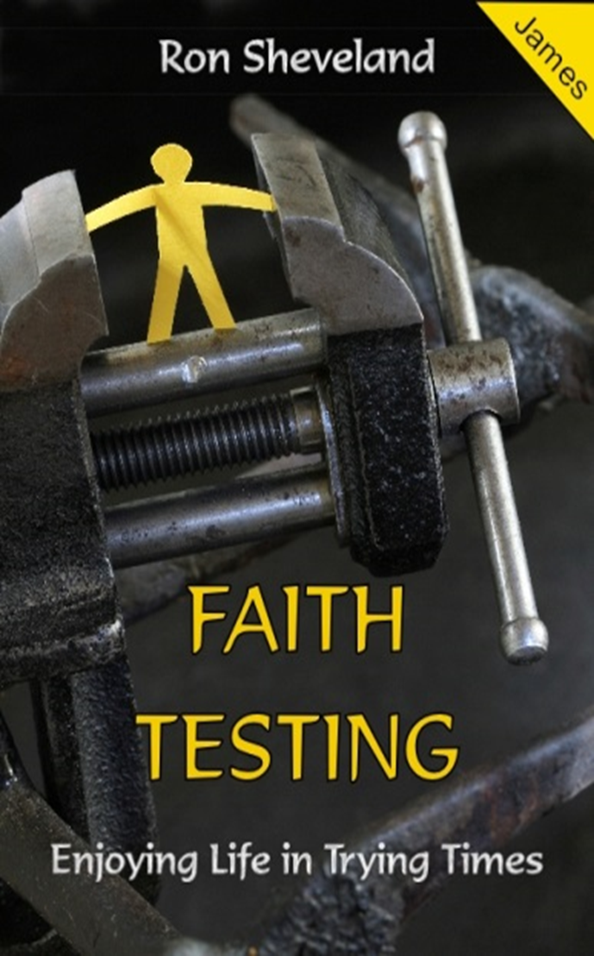
#3
THE BAIT & THE HOOK
James 1:13-18

