FAITH? YES, IN DEED!
Testing Your Faith by Your Works
James 2:14-26

All through his book James has been giving us a series of tests designed to help us examine the quality of our faith. Each of them has been very important. But today we will study the test that is by far the most critical. Why? Because if you did poorly on the others you would miss out on the abundant life God desires for you to experience. But if you fail this test you will not only miss the abundant life that you can have here on earth you will also miss the eternal life that you can have in heaven. This is one test that you dare not flunk!

TEXT

¹⁴What good is it, my brothers, if a man claims to have faith but has no deeds? Can such faith save him? ¹⁵Suppose a brother or sister is without clothes is without clothes and daily food. ¹⁶ If one of you says to him, "Go, I wish you well; keep warm and well fed," but does nothing about his physical needs, what good is it? ¹⁷In the same way, faith by itself, if it is not accompanied by action, is dead.
¹⁸ But someone will say, "You have faith; I have deeds."
Show me your faith without deeds and I will show you my faith by what I do. ¹⁹ You believe that there is one God. Good! Even the demons believe that--and shudder.
²⁰ You foolish man, do you want evidence that faith is useless? ²¹Was not our ancestor Abraham considered righteous for what he did when he offered his son Isaac on the altar? ²²You see that his faith and his actions were working together, and his faith was made complete by what he did. ²³And the scripture was fulfilled that says, "Abraham believed God, and it was credited to him as righteousness," and he was called God's friend. ²⁴You see that a person is justified by what he does and not by faith alone.
²⁵In the same way, was not even Rahab the prostitute considered righteous for what she did when she gave lodging to the spies and sent them off in a different direction? ²⁶As the body without the spirit is dead, so faith without deeds is dead.

OUTLINE

I. An Unproductive Dead Faith Results In Damnation (14-19)

A. The Big Question (14) What good is it, my brothers, if a man claims to have faith but has no deeds? Can such faith save him?

B. The Critical Answer (15-19)

1. Saving Faith Is More Than an Empty Profession (15-17)

2. Saving Faith Is More Than a Mental Acceptance of Biblical Facts (18-19)

II. A Productive Living Faith Results In Salvation (20-26)

INTERACTIVE QUESTIONS

1. What is faith?

2. Define the minimum biblical requirements for salvation.

3. What did Abraham do to show his faith? (2:21-23)

4. What made Abraham righteous? (2:23)

5. How are Abraham and Rahab dissimilar? What do they have in common? (2:21-26)

6. Do Paul and James contradict each other? Why or why not? How do you reconcile their teachings?

7. How is a person justified before God? (2:24)

8. How healthy is your faith? Is it a living, fruitful faith or a dead, useless faith?

9. In what areas of your life do you want to begin acting more like a faith-filled Christian?

10. In what home, work, or neighborhood situations might you be able to show faith/deeds this week? How?

Ephesians 2:8-10 For it is by grace you have been saved, through faith—and this is not from yourselves, it is the gift of God— not by works, so that no one can boast. For we are God’s handiwork, created in Christ Jesus to do good works, which God prepared in advance for us to do.

2 Corinthians 13:5 Examine yourselves to see whether you are in the faith; test yourselves. Do you not realize that Christ Jesus is in you—unless, of course, you fail the test?

Please prepare for the next study by reading James 3:1-12
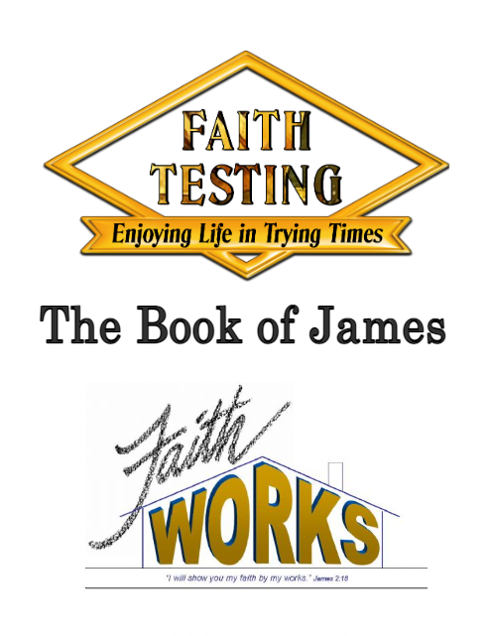
#6
FAITH? YES, IN DEED!
James 2:14-26

