"WISE or OTHERWISE"
Testing Your Faith by Your Wisdom Source
James 3:13-18

J
ames often returns to themes that he has taught about earlier in his letter. And that is what he does now with the topic of “wisdom.”

In the first chapter we are told to request wisdom from God so that we get a proper perspective of our trials. In the 10th century a writer named Oecumenius wrote a Commentary on James in which he said, “James calls wisdom the cause of perfection. He knows that faith is tried and tested in affliction. There is no need to ask God for perfect people. What we need are wise people. This is why he encourages those who want to be on top of their afflictions to ask God for wisdom.”
Now in chapter three, James asks, “Who is the wise and understanding among you? From the answers given to that root question, we discover what true wisdom is, where it comes from and how it is manifested.
When God allowed Solomon to make any request, the ruler said, “Give me wisdom and knowledge.” If that is what you also desire, God will give it to you through His Word and Spirit. This passage is one of the most specific teachings on wisdom in the entire Bible.

Text

¹³ Who is wise and understanding among you? Let him show it by his good life, by deeds done in the humility that comes from wisdom. ¹⁴ But if you harbor bitter envy and selfish ambition in your hearts, do not boast about it or deny the truth. ¹⁵ Such "wisdom" does not come down from heaven but is earthly, unspiritual, of the devil. ¹⁶ For where you have envy and selfish ambition, there you find disorder and every evil practice. ¹⁷ But the wisdom that comes from heaven is first of all pure; then peace-loving, considerate, submissive, full of mercy and good fruit, impartial and sincere. ¹⁸ Peacemakers who sow in peace raise a harvest of righteousness.

OUTLINE

I. Who Are The Wise Among You? (3:13)

II. What Is False Wisdom? (3:14-16)

A. Its Motivation (14) (SOIL)

1. Bitter Envy
2. Selfish Ambition

B. Its Characteristics (15) (ROOT)

1. It is "earthly" rather than heavenly
2. It is "natural" rather than supernatural
3. It is "of the devil" rather than of God

C. Its Results (16) (FRUIT)

1. Disorder
2. Every Evil Practice

III. What Is True Wisdom? (3:17-18)

A. Its Characteristics (17)

1. Pure
2. Peace-loving
3. Considerate
4. Submissive
5. Full of mercy and good fruit
6. Impartial
7. Sincere

B. Its Results (18)

1. Peace
2. Righteousness
INTERACTIVE QUESTIONS

These questions will help you understand and apply the text. You can use them personally or with a group or study partner.

3:13-18 Testing Your Faith by Your Wisdom Source

1. How do the “wise and understanding” demonstrate wisdom?

2. How do you know who truly speaks for God?

3. Describe true wisdom. Describe false wisdom.

4. How are Galatians 5 and James 3:13-18 related?

5. How can a person demonstrate wisdom and understanding? (3:13)

6. What is wrong with the "wisdom" of a selfish and bitter person? (3:14-15)

7. How does a wise person act? (3:17-18)

8. How can we get or experience heavenly wisdom?

9. What can you do this week to seek God's wisdom?

10. How are you using heavenly wisdom to maintain peaceful relations with family, friends and/or co-workers?

Please prepare for the next study by reading James 4:1-10
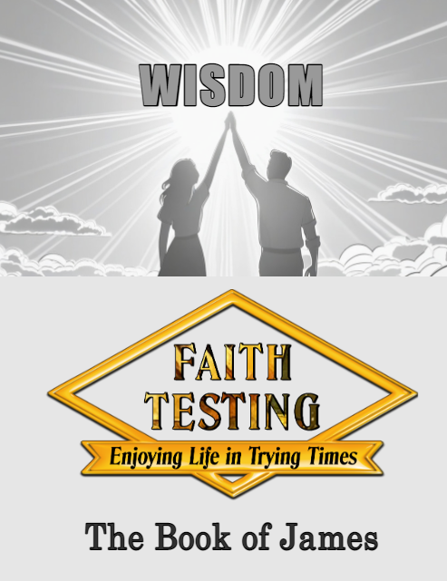
#8
"WISE OR OTHER WISE"
James 3:13-18

