"FIGHTING, FLIRTING & MAKING UP"
Testing Your Faith by Conflict
James 4:1-10
J
ames, in the last part of chapter three, described two kinds of wisdom. False wisdom that emanates from the world, the flesh and the devil, is full of “bitter envy and selfish ambition.” It culminates “in disorder and every evil practice.” “But the wisdom that comes from heaven,” on the other hand, “is first of all pure; then peace-loving, considerate, submissive, full of mercy and good fruit, impartial and sincere. Peacemakers who sow in peace reap a harvest of righteousness.” If peace is the outcome of godly wisdom, then “what causes fights and quarrels among you?” That is the key question that is answered in today’s text.
TEXT
"¹What causes fights and quarrels among you? Don't they come from your desires that battle within you? ²You want something but don't get it. You kill and covet, but you cannot have what you want. You quarrel and fight. You do not have, because you do not ask God. ³When you ask, you do not receive, because you ask with wrong motives, that you may spend what you get on your pleasures.
⁴You adulterous people, don't you know that friendship with the world is hatred toward God? Anyone who chooses to be a friend of the world becomes an enemy of God. ⁵Or do you think Scripture says without reason that the Spirit he caused to live within us longs jealously? ⁶But he gives us more grace. That is why Scripture says: "God opposes the proud but gives grace to the humble."
⁷Submit yourselves, then, to God. Resist the devil, and he will flee from you. ⁸Come near to God and he will come near to you. Wash your hands, you sinners, and purify your hearts, you double-minded. ⁹Grieve, mourn, and wail. Change your laughter to mourning and your joy to gloom. ¹⁰Humble yourselves before the Lord, and he will lift you up.

OUTLINE

I. FIGHTING: Fights With Others Originate With Fights Within Ourselves (4:1-3)

II. FLIRTING: We Cannot Respond to The World's Flirtations Without Cheating On Our Loving Lord (4:3-5)

- MAKING UP: Intimacy With God Can Be Restored By Our Humble Submission To Him (4:6-10)

A. God Offers His Grace to Those Who Will Humbly Submit to Him (vss. 6-7)

B. Humble Submission Will Require:

1. Resisting the Devil (vs.7)

2. Drawing Near to God (vs.8)

3. Broken-Hearted Repentance (vss. 8-10)

INTERACTIVE QUESTIONS

These questions will help you understand and apply the text. You can use them personally or with a group or study partner.

4:1-10 Testing Your Faith by Your Conflict

- What do families and friends commonly fight about?

- What is the root cause of fights and quarrels between people? (4:1-3)

- Explain in your own words the different ways that verse 2 has been understood.

- Read verse 5 in several English translations and note the dif-ferences

- When does God give us grace? (4:6)

- How did James describe the way we should come to God? (4:7-10)

- How can we reduce or remove the pride from our lives?

- Will you apply this passage to your life and use its principles to get right with God right now? What exactly will you do?

Please prepare for the next study by reading James 4:11-12

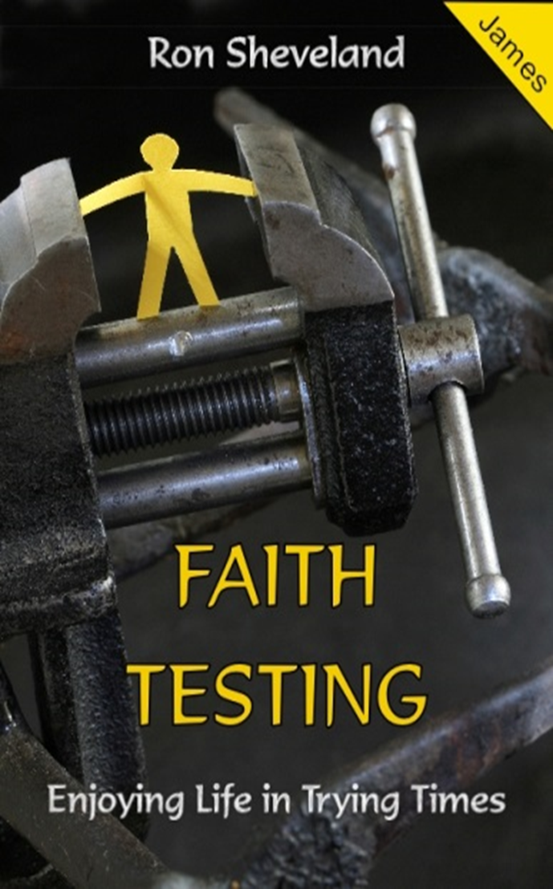
# 9
"FIGHTING, FLIRTING & MAKING UP"
James 4:1-10

